Emergencies  In case of emergency, a chaperone will call 911 if they have cell service. If they are out of cell range, they will try to get to the nearest ranger station. In an event that a group member is stuck or injured and cannot be moved two chaperones will be sent out to find help. No matter what the situation we will not separate the group.  Chaperones  Lee Johnson – lee.johnson@wdbqschools.org, Callie Leytem – callie.leytem@wdbqschools.org, Emma Horst – emma.horst@wdbqschools.org, Cassie Leitzen – cassie.leitzen@wdbqschools.org, Jennifer Cartee – Jennifer.cartee@wdbqschools.org, Stephani Escobedo-Vega – stephani.escobado-vega@wdbqschools.org, Kayla Pins – kayla.pins@wdbqschools.org, Cece Zangara  Commitment  I understand that I am asking a lot of the students, but in the past we have had issues with commitment. Therefore, I am asking that each of you sign a contract indicating that you are committed to this trip. If an emergency arises, I completely understand why you may need to back out of the trip; however, if you decide to back out of the trip I am asking that you pay your fees at $450. Since this trip is divided equally amongst students, I will not charge the other 23 students more because you backed out. I start making payments and reservations almost instantly once I know who is going on the trip. If you are still exited and wanting to go on the trip of a lifetime then get ready for round 3.  Questions  Contact Cece Zangara – Cecelia.zangara@wdbqschools.org |  |  | Utah 2018 – Student Booklet  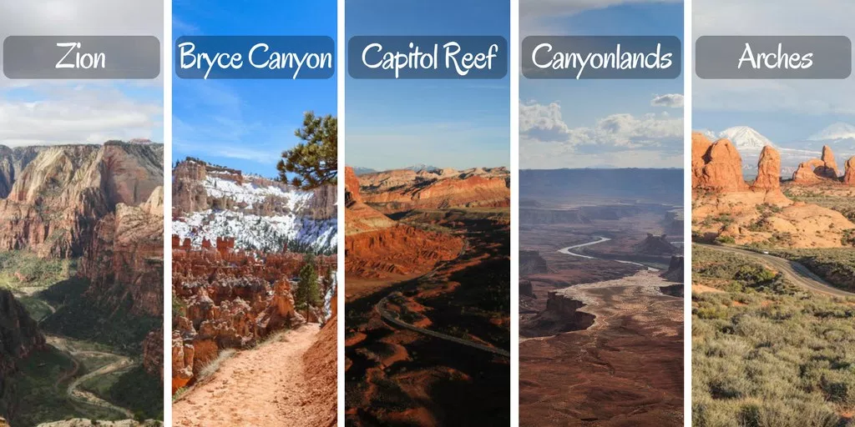  Backpacking Bobcats  - Utah National Parks 2018

Table of Contents  Overview of student roles 1  Practice Hikes 1  Practice Overnight 2  Chores………………..………………………………………………………………………2  Discipline Procedure 3  Trip Itinerary 4-5  Equipment 5  Group Equipment 5  Emergencies 6  Chaperones...……………………………………………………………………………………6  Commitment……………………………………………………………………………………..6  Question ……. ……………………………………………………………………………………6 |  |  | Day 8 – June 16th  Capitol Reef - Rim overlook hike (5 mi). Drive to Canyonlands National Park (2.5 hrs). Hike Cave Spring Trail (1mi) or The join trail (2mi)  Day 9 – June 17th  Hike Lost Canyon (8.6 mi) at Canyonlands. Drive to Arches National Park (approx. 30 mins). Hike Delicate Arche (3 mi) in the evening.  Day 10 – June 18th  Hike Devils Garden Primitive Loop (7.2mi). Leave for Grand Junction, CO after dinner (5 hrs)  Day 11 – June 19th  Drive from Grand Junction, CO to Epworth, IA (10 hrs)  Equipment  All individual & group equipment will be provided for you at no cost. If an item is lost or returned damaged, you will pay for the item.  All chaperones will be responsible for their group’s equipment. This means each chaperone will have a list of who has what to ensure all equipment is returned and in good condition. All chaperones will be present at the equipment check out and check in dates to assist with their group’s equipment. We will do equipment check out on a weekend after the final 24 have been picked and students have paid their $100 deposit. The following is a list of all provided equipment: REI mummy sleeping bag ($130), Kelty Redstone 70L Backpack($150), Kloud City Rain cover (L)($7), ALPS lightweight Sleeping Pad($45), Marmot Aspen Tent, & Tent Footprint ($200).  The following items will be provided to each group: MSR Miniworks Water Microfilter ($90), MSR Dragonfly Stove ($140), MSR Fuel Bottles (30oz)($22), GSI Bugaboo Camper Cook set($110), 2.5 Gallon Water Jug($10), MSR Super Fuel, GSI outdoors crossover kitchen set($40).
 |  |  | 5

Trip Itinerary  This itinerary is subject to change depending on natural disasters, and availability.  “Life is a great adventure or nothing at all.” – Helen Keller  Day 1 – June 9th  Drive from Epworth to Grand Junction, Colorado (approx. 16 hrs)  Overnight at a hotel  Day 2 – June 10th  Drive from Grand Junction, Colorado to Zion National Park (approx. 6 hrs)  Day 3 – June 11th  Groups 1 & 2 Hike the Narrows  Groups 3 & 4 Hike to Angels Landing  Day 4 – June 12th  Groups 1 & 2 Hike to Angles Landing  Groups 3 & 4 Hike the Narrows  All groups drive to Bryce Canyon National Park (1.5 hrs). Groups 1 & 3 Hike from Rainbow Point to Iron Spring (4 mi). Groups 2 & 4 hike from Bryce point to yellow creek group site (4 mi).  Day 5 – June 13th  Groups 1 & 3 Hike from iron spring to Right Fork (9 mi)  Groups 2 & 4 Hike from yellow creek to Swamp Canyon (8 mi)  Day 6 – June 14th  Groups 1 & 3 Hike from Right Fork to Bryce Canyon (10.5 mi)  Groups 2 & 4 Hike from Swamp Canyon to Rainbow Point (11mi)  Day 7 – June 15th  Drive from Bryce Canyon to Capitol Reef National Park (2.5 hrs). Grand Walsh hike (5 mi). Explore historic orchard & buildings. |  |  | Student Roles  Overview  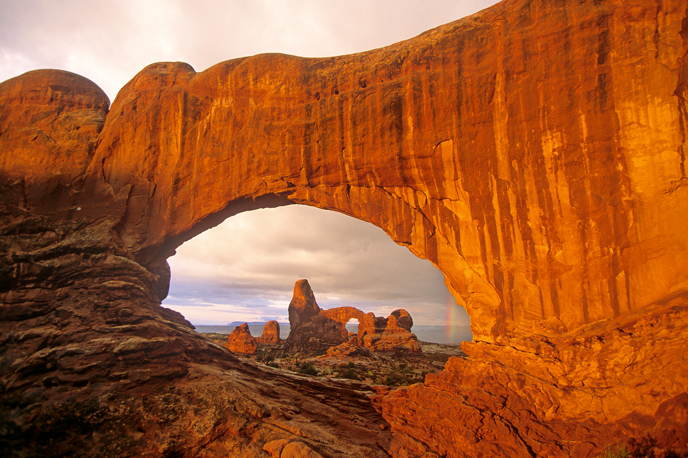 Your main role as a student is to work together with your peers, stay safe and have fun! Some expectations are: 1. Participate in the group fundraiser. 2. Assist with chores 3. Hike, you need to be physically able to hike 5-13 miles in desert. Some hikes will require us to cross rivers, through rivers, climb ladders and go to extreme heights. 4. Inform your chaperone of where you are at always. 5. Take care of your equipment and respect school property. 6. Participate in a daily journal/blog post. 7. Upload your pictures at the end of the trip. 8. Complete various assignments as assigned before/on the trip. 9. Stay Spark (positive) 10. Practice leave no trace principals.  Practice Hikes  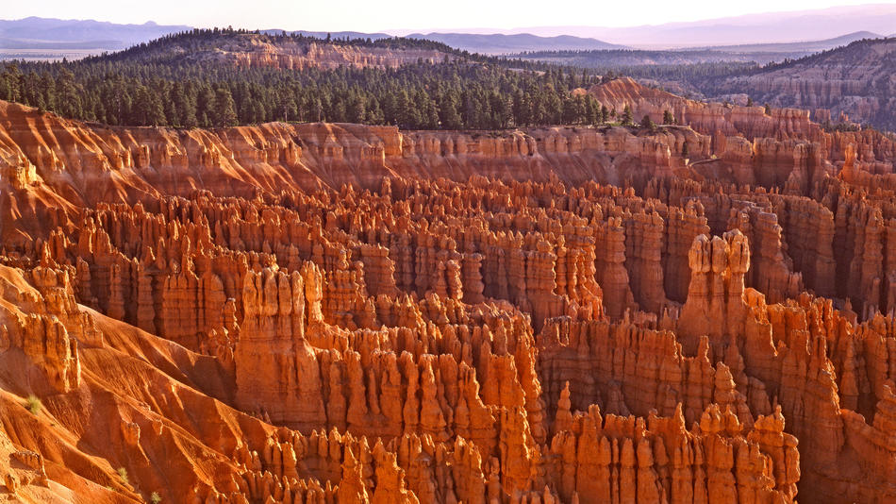 All students will attend 2 practice hikes per month. These practice hikes are at Swiss Valley Nature Center or Mines of Spain (both in Dubuque). My goal is to complete a type of service project for the park during each practice hike. Hikes will be on Sundays starting at 12:15. A list of practice hikes will be included.
4 |  |  | 1

Hike Dates:  October 8(SV) & 22(MoS)  November 4-5 (overnight in yellow river)  December 3 (SV)  January 14 (SV) & 28 (MoS)  February 11 (SV) & 25 (MoS)  March 11 (SV) & 25 (MoS)  April 8 (SV) & 28-29 (overnight in yellow river)  May 6 (SV) & 20 (MoS)  June 9-20 (TRIP)  Practice Overnight  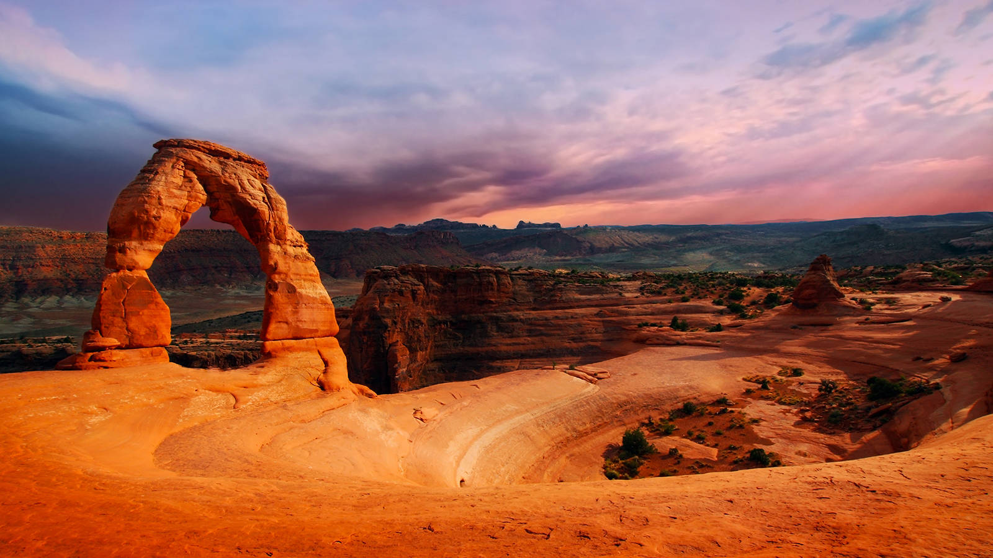 All students need to be at the practice overnight. We will travel to Yellow River State Park and hike 13 miles in two days. We leave WDHS on Saturday morning and return on Sunday afternoon. This is a great way for everyone to learn how to use our equipment, practice cooking on our stoves and get to know their students!! Our first practice overnight is scheduled for November 4-5 & our second is April 28-29.  Chores  All students will participate in daily chores set up by their chaperones. This includes setting up the tents, cooking dinner, purifying water, cleaning up the dishes, and putting everything away before bed. Most of the chores are simple and will be easy to complete at base camp. Moving into the backcountry provides new challenges, but a good chore list will help everyone understand what is expected of them. |  |  | Discipline  The overall goal of this trip is to ensure the safety of all students. We have never had an issue in the past with discipline and hope that continues in 2018.  WDHS Code of Conduct – If a student is in possession of illegal substances they will be sent home on their parent’s dollar. No student is allowed to be in possession of drugs or alcohol while on this trip. Any other paraphernalia associated with illegal substances is also banned from this trip. Again, if a student is caught with these items the parents will be notified and arrangements will be made to send them home.  WDHS Backpacking Bobcats Code of Conduct – Students with an attitude/behavior issue (ex: not following directions or sassing off to an adult) will be put on a 3 - strike system.  Strike 1 – Extra Chores for the evening (this will include dish duty and clean up)  Strike 2 – Extra Chores for the length of the trip (this will include dish duty and clean up). The parents will also be notified of the student’s behavior if cell service permits.  Strike 3 – The parents will be notified and arrangements will be made to send them home.
2 |  |  | 3

